ข้อสอบห้องแต่งตัว
- What can you in the dressing room?
  - cup and bowls
  - calculator and file holder
  - brush and mop
  - dress and skirt
- If you want to go to the beach , what would you like to put in you bag?
  - pajamas and skirt
  - raincoat and sweater
  - swimsuit and sunglasses
  - pant and jeans
- In the hot season, I wear………………………… .
  - T shirt and shorts
  - Raincoat and skirt
  - Sweater and coat
  - Jeans and jacket


Where can we find them?
  - In the kitchen
  - In the dressing room
  - In the dining room
  - In the bathroom

- ให้นักเรียนเลือกคำศัพท์ให้ตรงกับรูปภาพ
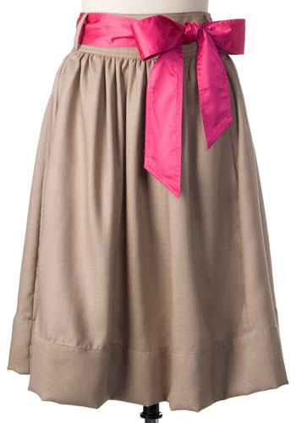

  - dress
  - skirt
  - sneakers
  - coat
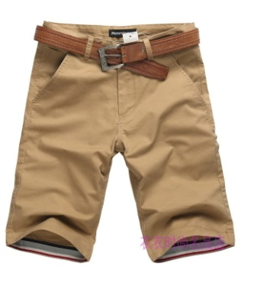
k
What can you do with this?

- I can drink it.
- I can read it.
- I can wear it.
- I can play it.
เฉลย
- d
- c
- a
- b
- b
- c

