Students Car Rally Handbook
27 August 2014
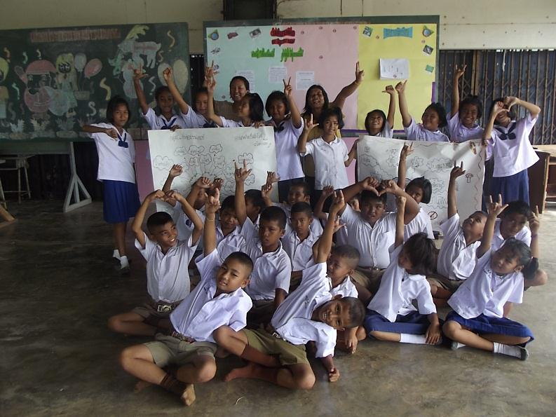

Bankohkob School
Phatthalung Primary Educational Service
Area Office 2


Read and do activities
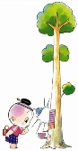
The First Point
1. Write the name of members in your group.
…………………………………………………………………………………………………………………………………………………………………………………………………………………………………………………………………………………………………………………………………………

2. All of members in your group take photo together at Bankohkob school. Upload your photo online or facebook.

3. Get on your car and drive it to the second point.

The Second Point

4. Park your car at Bankohkob Forest Protection Unit.

5. Take the photo and write its name animals in English language.
………………………………………………………………………………………………………………………………………………………………………………………………………………………………………………………………………………………………………………………………………………….................................................................................

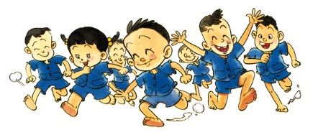

The Fifth Point

13. Park your car at Bankohsua School.

14. All of your group shout Hello!

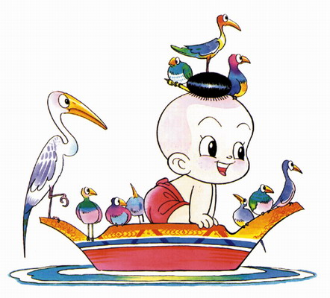

The Third Point

6. Park your car at Police Booth.

7. Take the photo with the policeman
Ask the policeman about.
Name …………………………………………….
Surname ……………………………………………
Nickname ……………………………………………
Age ……………………………………………

How many policeman are there at the police Booth.
………………………………………………………………………………………………………………………………………………………………………………………………………………………………………………………

8. Draw the picture of the policeman.

9. Get on your car and drive it to the fourth point.

The Fourth Point

10. Park your car at the grocery.
Buy some candies and water.

11. Don’t forget to take the photo of your group with some candies and water and take photo with beautiful seller.

12. Get on your car and drive it to the fifth point.

